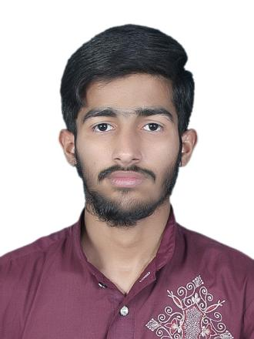

**ABDUL REHMAN**

Quick learner, problem solver, Innovator

**EDUCATION**

* **MATRICULATION (**2015 - 17**)**
* **Govt. Islah-e-Moashra H/S, Shad Bagh, Lahore.**
* Computer SCIENCE. **(** 90.6% marks**)**
* **INTERMEDIATE (**2017 - 19**)**
* **Punjab College of Information Technology, Lahore.**
* ICS **(** 84.0% marks**)**
* **GRADUATION (**2019 - Cont.**)**
* **Punjab University College of Information Technology.**
* BSSE **(**3.20 CGPA**)**

**PROFILE**

**FATHER NAME :** Muhammad Ikram

**DATE OF BIRTH :** 01 may, 2001

**CNIC NO. :** 35202-0353013-5

**Gender :** Male

**NATIONALITY :** Pakistani

**LANGUAGE :** Urdu| English

**CONTACT**

*bsef19m005@pucit.edu.pk*



**(**+92**)**309-1149236



**EXPERIENCE**

* **Home Tuition -** I have been working home tuition for 3.5 years to meet my university expenses.
* **Fresher -** I am studying in pucit, one of the top universities of IT. I have only the experience of small semester projects. I want to work in your company to get real experience of work.

*https://www.linkedin.com/in/abdul-rehman-580260241*



Badami Bagh Lahore, Pakistan



**LANGUAGE**

* C++ , C# , Python, Java
* HTML , CSS, JavaScript, SQL

**SKILLS**

* .NET Framework
* Bootstrap
* My SQL, SQL Server
* OOAD
* Data Structure
* Algorithm

**HOBBIES**

Traveling



Playing Cricket



Leaning from YouTube

